**TURBO CAR RENTAL**

USER MANUAL

**Submitted by**:

Valenzona, Mark Joseph

Paraguya, André Paulo

**Submitted to**:

Sir [Paul John Parreño](https://www.facebook.com/paul.j.parreno?fref=nf)

**Submitted on**:

October 23, 2014

**TABLE OF CONTENTS**

**SYSTEM OVERVIEW** II

**SIGN UP** 1

**LOGIN** 2

**FORGOT PASSWORD** 3

**NAVIGATION DRAWER** 4

**RENTALS** 5

**HISTORY** 6

**RENT A CAR** 7

**DRIVER PROFILE** 8

**CAR RENTAL FORM** 9

**PROFILE** 10

**EDIT PROFILE** 11

**NEWS** 12

**CONTACT** 13

**ABOUT** 14

**LOG OUT** 15

# **SYSTEM OVERVIEW**

* The Turbo Car Rental application is a car reservation system which caters to customers who have just arrived, or plan to be in the vicinity of Cebu and want to have a temporary car for personal use.
* The application is developed using Android Jellybean.
* End users will navigate through the application using a GUI.
* An unregistered user may need to sign up for an account to use the application.
* The app allows an end user to view relevant news and events.
* The app allows an end user to reserve a car by undergoing a short procedure.
* The app allows an end user to view or change his/her profile information.
* The app allows an end user to view the company’s profile information.
* The app allows an end user to view his/her reservations. A reservation can either be PENDING, ACTIVE, CANCELLED, or FINISHED.
* The app allows end users to log out of their accounts anytime.

# **SIGN UP**

By selecting the “Sign Up for Turbo” link, you will be redirected to the Registration page after clicking the link.

Supply all forms with the required data. Note: It’s necessary to upload a valid photo. This will be used for identification

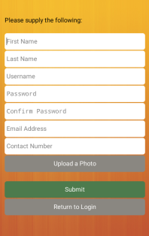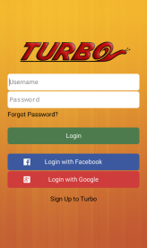After supplying all the required data and pressing the Submit button, you will be redirected to the login page.

# **LOGIN**

On the login page, the user will be asked to input his/her registered username and password in order to continue. 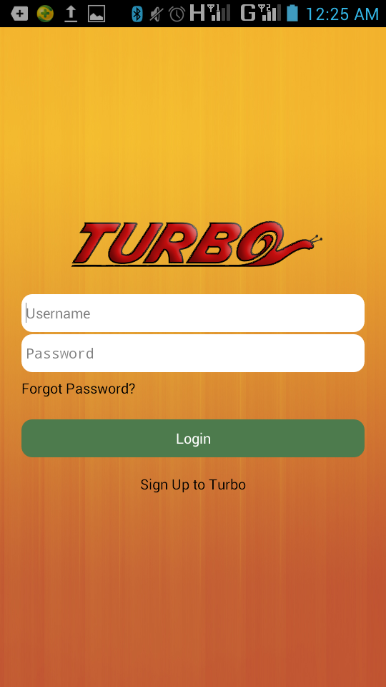

# **FORGOT PASSWORD**

On the login page, a registered user may select the “Forgot Password?” link if ever he/she forgets his/her password.

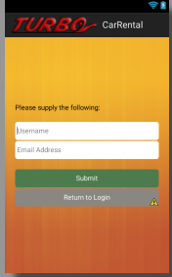After the “Forgot Password” link is pressed, the user is redirected to a page where he/she is asked to input his/her username and email address. The username will be the identifier for the user account and the email address will be where the password will be sent.

# **NAVIGATION DRAWER**

The application allows the user to conveniently navigate through different pages with the help of a navigation drawer.

The navigation drawer can be accessed by pressing the menu icon on the top-left corner of the screen.

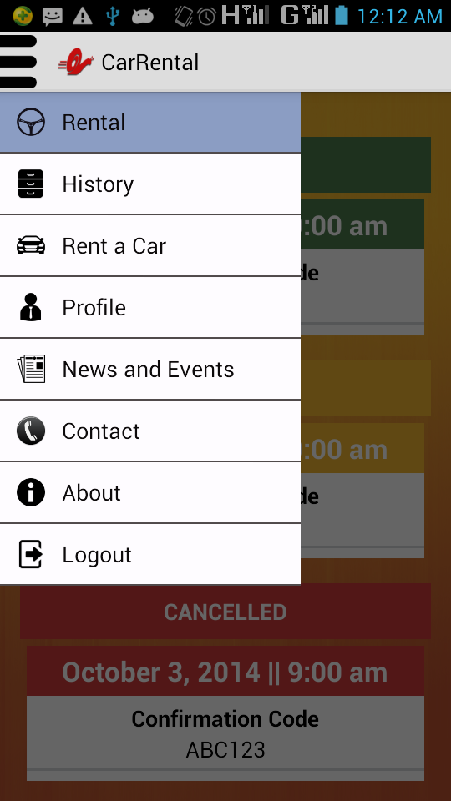

# **RENTALS**

The Rentals page can be accessed through the rentals icon in the navigation drawer. When a user logs in, he/she is redirected to the Rentals Page. The page displays the car reservations of the user. The reservations are categorized under PENDING, ACTIVE, CANCELLED, and FINISHED. The user may cancel a Pending Reservation by selecting the Cancel Reservation button.

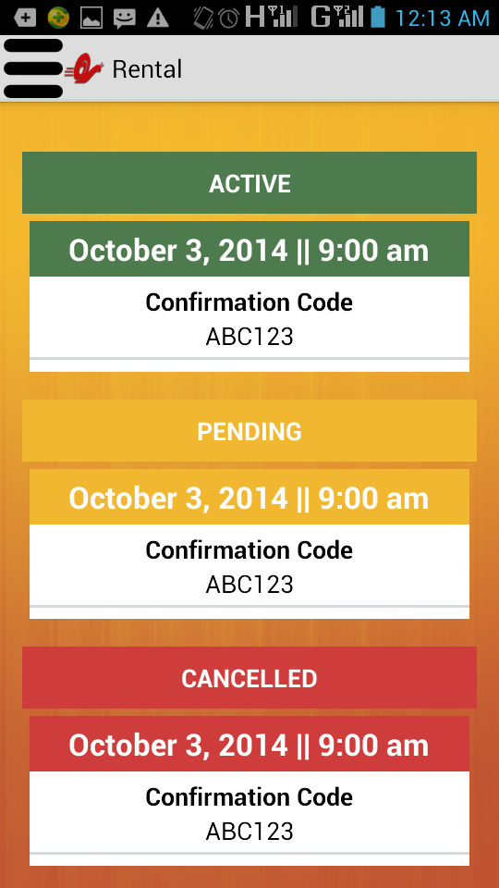

# **HISTORY**

The History page can be accessed through the history icon in the navigation drawer. The user may view his/her previous car reservations through the History page. The page displays the CANCELLED, and FINISHED car rentals by the user.

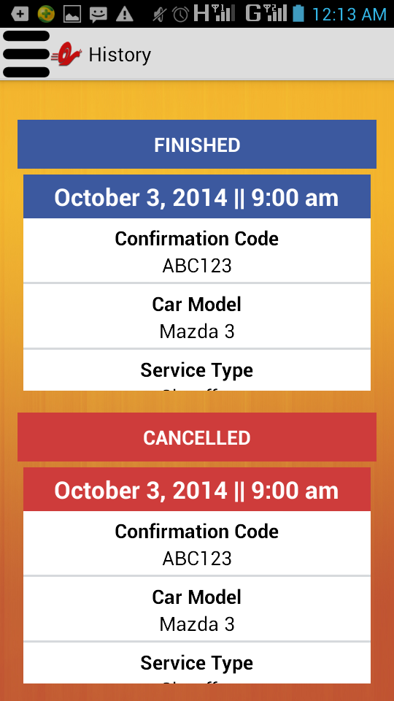

# **RENT A CAR**

The Rent a Car process can be accessed through the rent a car icon in the navigation drawer. The user first chooses the type of car. After choosing a car, he/she may view more information about the car, view the driver's profile, or rent the chosen car.

If the user chooses to view more information about the car, the user is sent to a webpage which displays the car's information.

If the user chooses to view the driver's profile, he/she will be sent to the driver page.

If the user chooses to rent the car, he/she will be sent to the car rental form

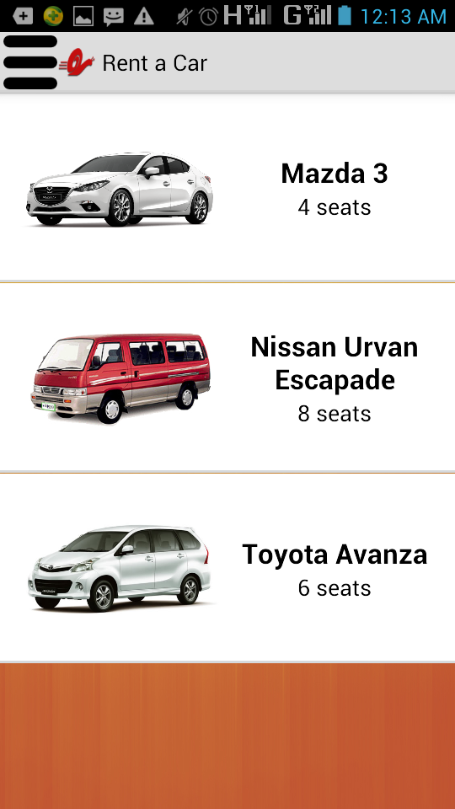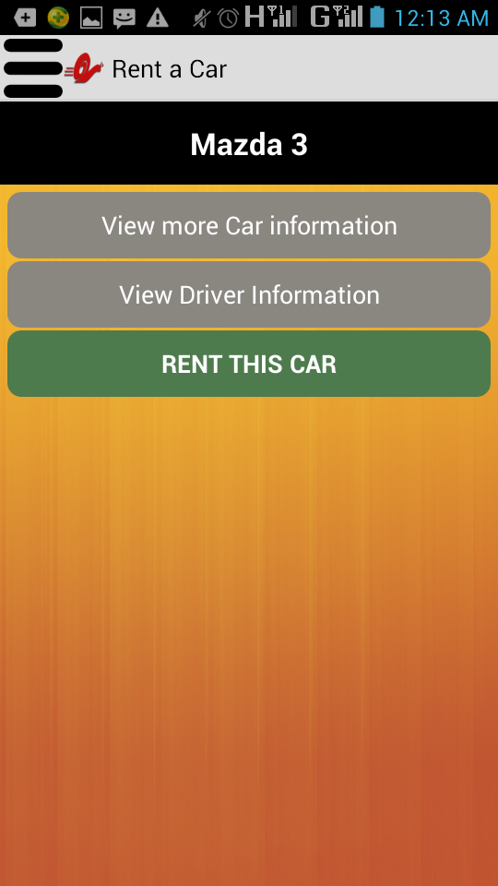

# **DRIVER PROFILE**

The user may access the driver profile by pressing the View Driver Profile Button in the car renting process.

The page displays relevant driver information.

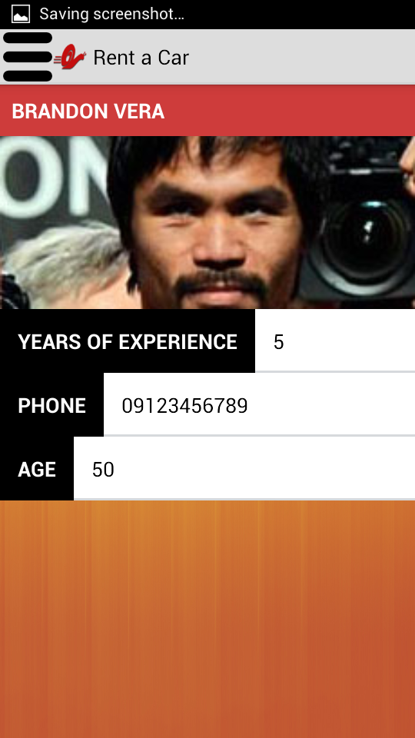

# **CAR RENTAL FORM**

The car rental form may be accessed by selecting the Rent This Car button in the car rental process.

The page displays information required to finish the car rental process.

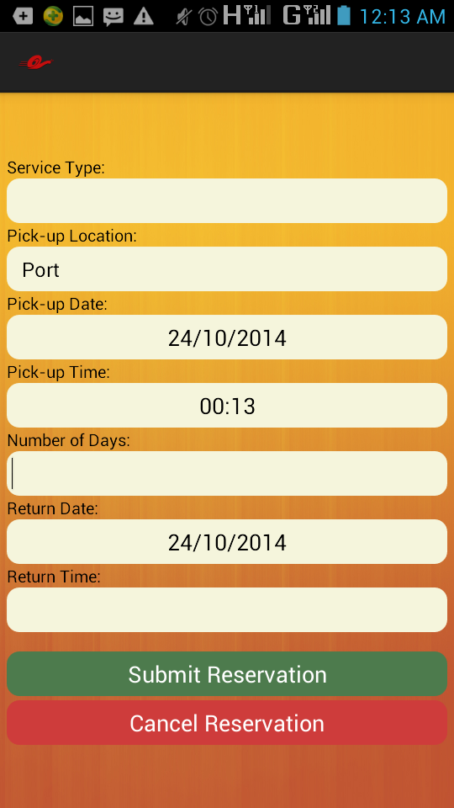

# **PROFILE**

The Profile page may be accessed through the profile icon in the navigation drawer. The page displays relevant user information. The user may choose to edit his profile by selecting the Edit Profile button on the page.

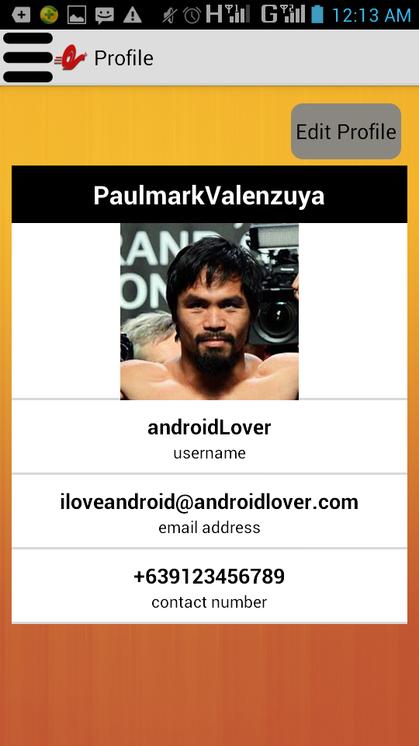

# **EDIT PROFILE**

The Edit Profile page can be accessed through the Profile page. The user may update his/her user account through this page.

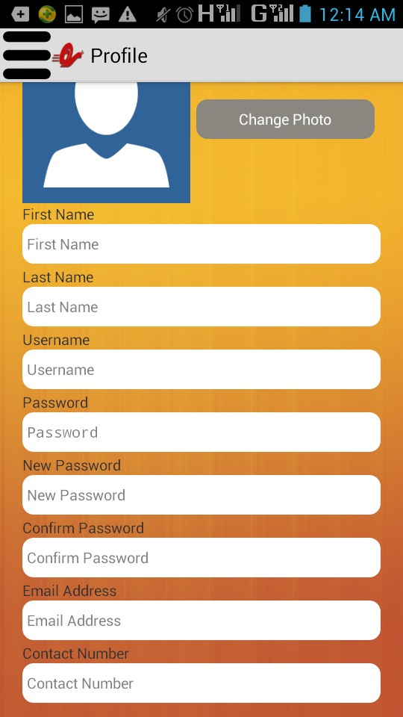

# **NEWS**

The News page can be accessed through the news icon in the navigation drawer. The news page contains a list of hot topics. Selecting an element on the list will redirect you to the full story of the news.

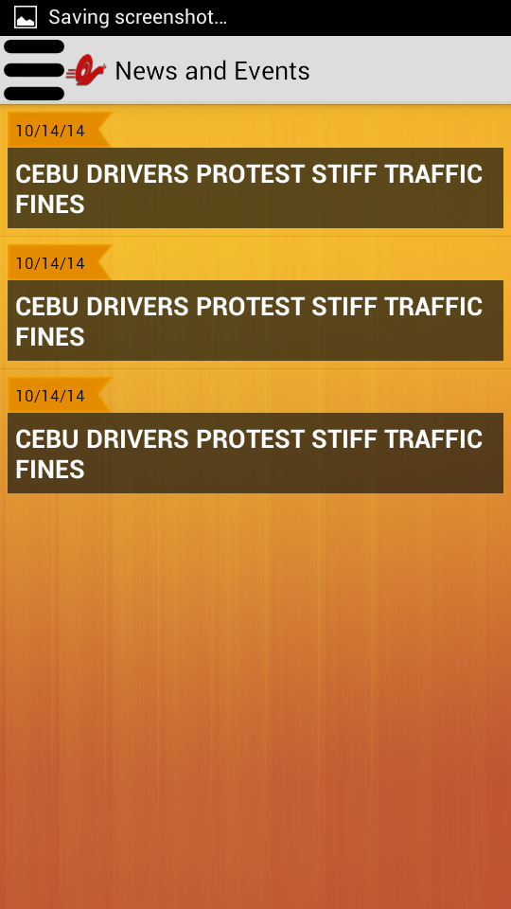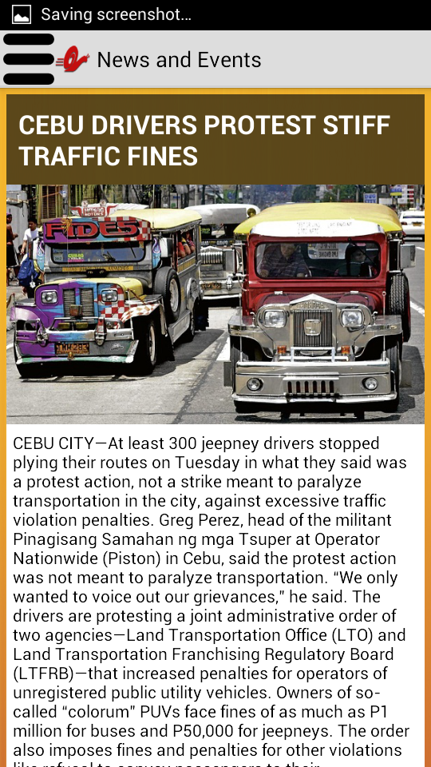

# **CONTACT**

The Contact page can be accessed through the contact icon in the navigation drawer. The page contains information with regard to the company's location, contact number, and email address.

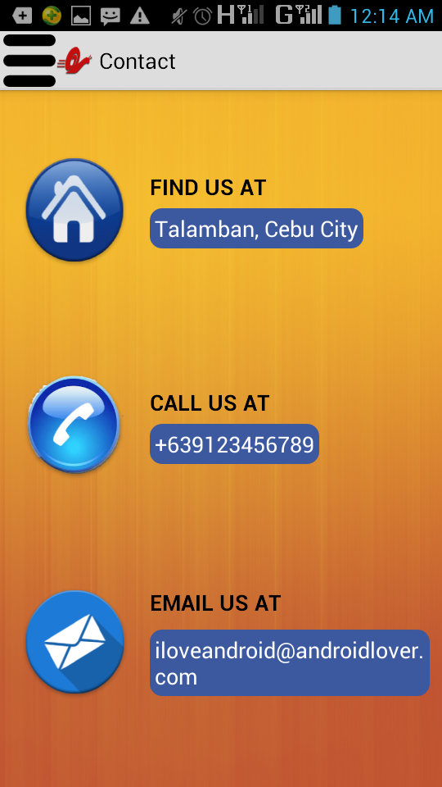

# **ABOUT**

The About page can be accessed through the about icon in the navigation drawer. The page contains information with regard to what the company is and what the company offers.

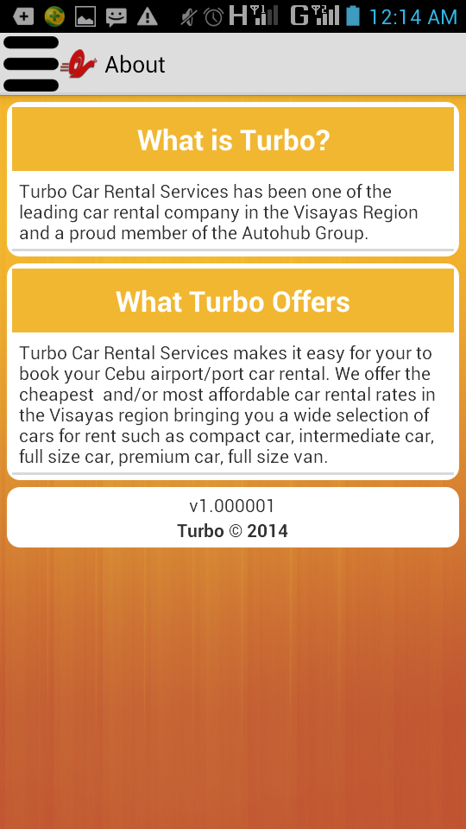

# **LOG OUT**

The user may log out from his/her account anytime through the log out icon on the navigation drawer.

